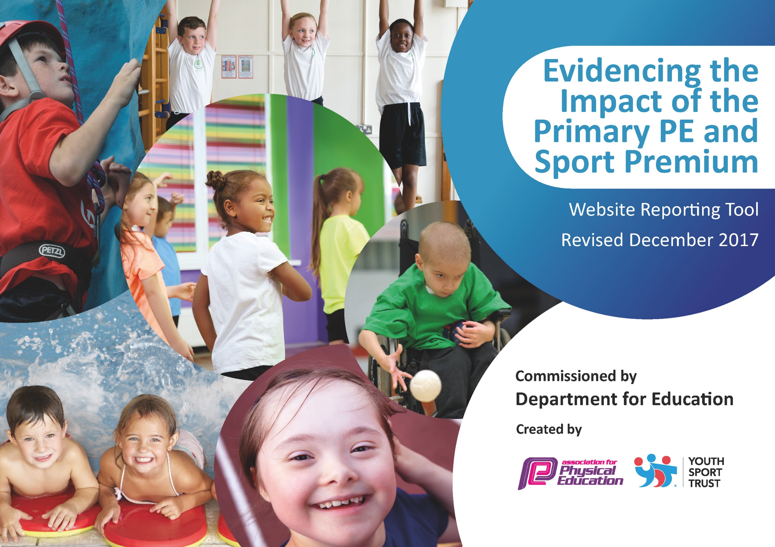

Schools must use the funding to make additional and sustainable improvements to the quality of PE and sport they offer. This means that you should use the Primary PE and Sport Premium to:

- develop or add to the PE and sport activities that your school already offers
- build capacity and capability within the school to ensure that improvements made now will benefit pupils joining the school in future years

Please visit gov.uk for the revised DfE guidance including the 5 key indicators across which schools should demonstrate an improvement. This document will help you to review your provision and to report your spend. DfE encourages schools to use this template as an effective way of meeting the reporting requirements of the Primary PE and Sport Premium.

We recommend you start by reflecting on the impact of current provision and reviewing the previous spend.
Under the Ofsted Schools Inspection Framework, inspectors will assess how effectively leaders use
the Primary PE and Sport Premium and measure its impact on outcomes for pupils, and how effectively governors hold them to account
for this.

Schools are required to publish details of how they spend this funding as well as on the impact it has on pupils’ PE
and sport participation and attainment.
We recommend regularly updating the table and
publishing it on your website as evidence
of your ongoing review into how you are using the money
to secure maximum, sustainable impact. To see an example of how to complete the table please click HERE.

Meeting national curriculum requirements for swimming and water safety | Please complete all of the below*:
What percentage of your current Year 6 cohort swim competently, confidently and proficiently over a distance of at least 25 metres? | 100%
What percentage of your current Year 6 cohort use a range of strokes effectively [for example, front crawl, backstroke and breaststroke]? | 100%
What percentage of your current Year 6 cohort perform safe self-rescue in different water-based situations? | 100%
Schools can choose to use the Primary PE and Sport Premium to provide additional provision for swimming but this must be for activity over and above the national curriculum requirements. Have you used it in this way? | Yes
*Schools may wish to provide this information in April, just before the publication deadline.

Action Plan and Budget Tracking
Capture your intended annual spend against the 5 key indicators. Clarify the success criteria and evidence of impact that you intend to measure to evaluate for students today and for the future.

Academic Year: 2017/18 | Total fund allocated: £13,188  Planned spend: £14, 560 | Date Updated: October 2017
Key indicator 1: The engagement of all pupils in regular physical activity – Chief Medical Officer guidelines recommend that primary school children undertake at least 30 minutes of physical activity a day in school |  |  |  | Percentage of total allocation:
 |  |  |  | %
School focus with clarity on intended impact on pupils: | Actions to achieve: | Funding allocated: | Evidence and impact: | Sustainability and suggested next steps:
Ensuring pupils are active during lunch times and play time | Equipment to be purchased to encourage children to be active and engaged at break time  Year 5 /6 pupils to take part in Playmakers Award to encourage leadership and involvement in running play activities for the younger children in school  Whole school to take part in Skip2Bfit workshop, staff training and implementation of a Daily skipping challenge. | £500  £500  £350 workshop  £250 training session  £500 skipping challenge resources | All pupils engage in physical activity and are active during break times (observations, pupil conversations)  Children are engaged in activities set up and led by older children. Children who are trained are established as active ambassadors in school.  All pupils enjoy and engage in skipping challenge (skipping records)and increase personal best in challenge | This will be carried out on a two year rolling programme.  Ta’s to run lunchtime skipping clubs. Year 6 to train up new reception children each year.
Key indicator 2: The profile of PE and sport being raised across the school as a tool for whole school improvement |  |  |  | Percentage of total allocation:
 |  |  |  | %
School focus with clarity on intended impact on pupils: | Actions to achieve: | Funding allocated: | Evidence and impact: | Sustainability and suggested next steps:
School to achieve Bronze Active Award  Develop assessment tool to record and evidence progress in PE  Focus on Assessment of PE to evidence quality of teaching, learning and engagement in PE and sport | PE co-ordinator to register and complete audit for bronze award. Possible involvement of Angel Rhodes from Brid Sports partnership to support  Questionnaire to be designed to get an overview of sport activity in and out of school for pupils so that we can monitor increase over time. Gather data and analyse  Work with Staff and outside PE teacher to ensure that FLIC is being used to record progress in PE. These will then make an informed judgement about PE across the whole school and identify areas for development, CPD target etc. | 2 day release time £360  I day release time £180  1day release time £180 | School awarded Bronze award  School has an overview to be used year on year to track sport in school and level of activity and impact of funding.  Attainment and progress in PE is tracked effectively and used to inform further developments in this area. | Questionnaire and Assessment will be used year on year and used to inform Self evaluation.  Next steps to work towards achieving Silver active mark.  Gaps and children will be identified and activities can then be planned to help support with this.

Key indicator 3: Increased confidence, knowledge and skills of all staff in teaching PE and sport |  |  |  | Percentage of total allocation:
 |  |  |  | %
School focus with clarity on intended  impact on pupils: | Actions to achieve: | Funding  allocated: | Evidence and impact: | Sustainability and suggested  next steps:
Staff to develop PE skills by observing and working alongside Fiona Tuplin.  Invite sports specific coaches into school to develop ideas, skills and confidence | Fiona Tuplin to be employed deliver games lessons in school with support from Class teacher/TA  Coaches such as cricket, tennis gym etc to deliver activities to children. | £3500  £600 | Teachers /TA’s feel more confident and upskilled to deliver high quality PE (staff questionnaire) | Identify staff individual needs and address
Key indicator 4: Broader experience of a range of sports and activities offered to all pupils |  |  |  | Percentage of total allocation:
 |  |  |  | %
School focus with clarity on intended  impact on pupils: | Actions to achieve: | Funding  allocated: | Evidence and impact: | Sustainability and suggested  next steps:
All pupils to be given increased opportunities to participate in a wide range of sport and sporting activities.  All children in Ks to have access to swimming lessons regardless of whther they can swim 25 m. This will develop water safety skills and enjoyment. | PE lessons led by specialist PE teacher to provide experience of high level teaching and sport variety and to up skill staff.  Provide after school clubs which change focus half termly – First step sports and Fiona  Children to attend ‘festivals’ ensuring that all children in school experience competitive sport.  Liase with Driffield Pool to ensure lessons take place.  Visit the pool to look at impact of lessons | See above  First Steps £2500  Fiona £500  Transport costs £1000  £3000 | Children are experiencing a wider range of sporting activities.  Increased up take to after school clubs.  Targeted children attend after school clubs  Increase in number of children talking part in sports out of school as a result of getting interested in school.  Increase in number of pupils swimming by end of KS1, taking part in water safety, increased distance swimming and swimming for enjoyment. | Pupils knowledge and enjoyment of sport along with sign posting to out of school clubs will ensure pupils continue to take part in sporting activities in and out of school  Develop links with clubs further with taster sessions in school
Key indicator 5: Increased participation in competitive sport |  |  |  | Percentage of total allocation:
 |  |  |  | %
School focus with clarity on intended  impact on pupils: | Actions to achieve: | Funding  allocated: | Evidence and impact: | Sustainability and suggested  next steps:
To build up good links with our cluster schools, arrange and participate in inter school competitions.  To allow children to access a variety of competitive sports and move on to competition beyond the cluster. | Membership of Driffield and Wolds Sports partnership  Communicate with Bridlington Sports Partnership to try and gain access to more level 2 competitions  Liase with local clubs to create taster sessions for signposting | £640 | Increased number of children taking part in competitions with local schools.  Increase in number of pupils taking part in after school competitions  Increase in number of children attending sporting activities out of school | Increase in attendance, the quality of competition as more children attend and develop skills and experience and will ensure activities are sustainable for the future.

